
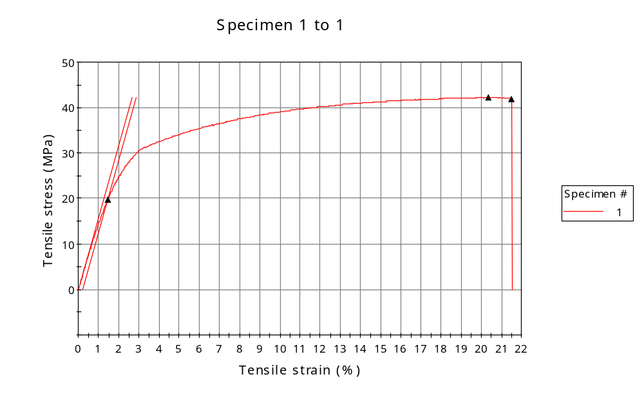
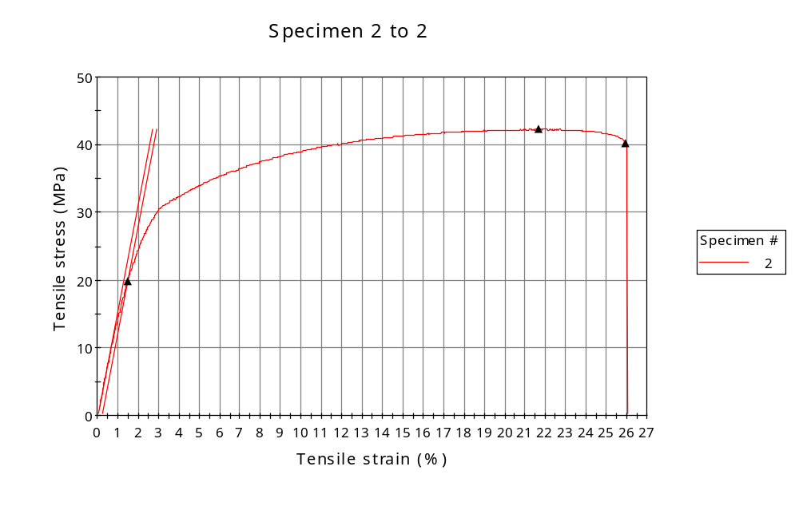
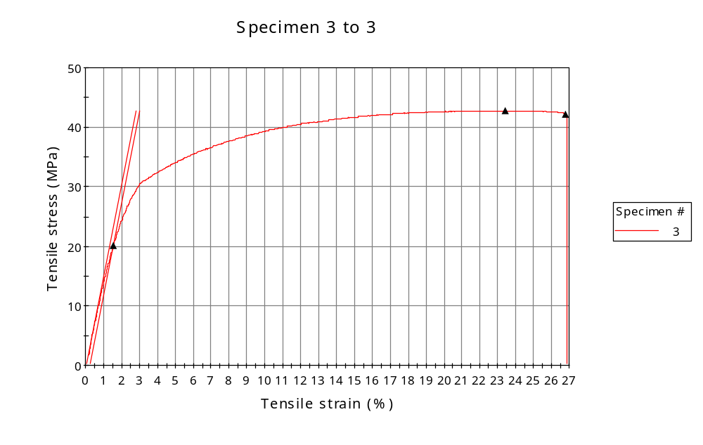
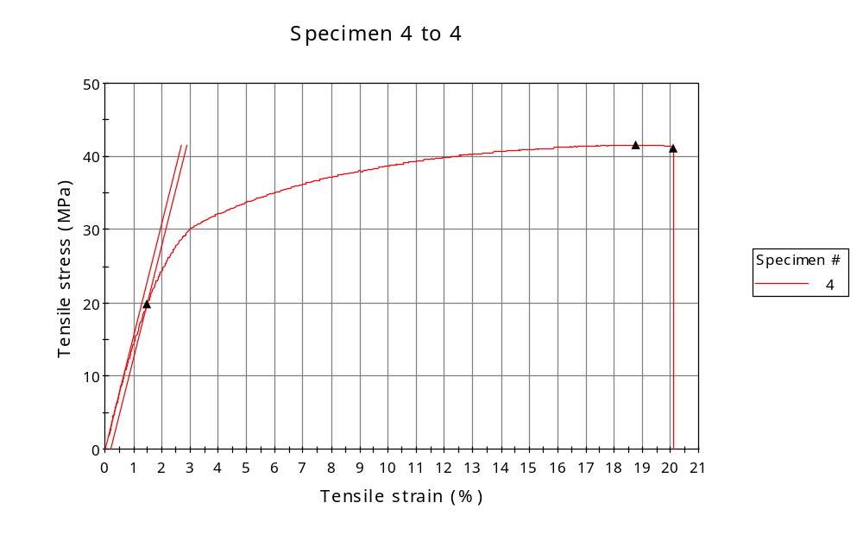
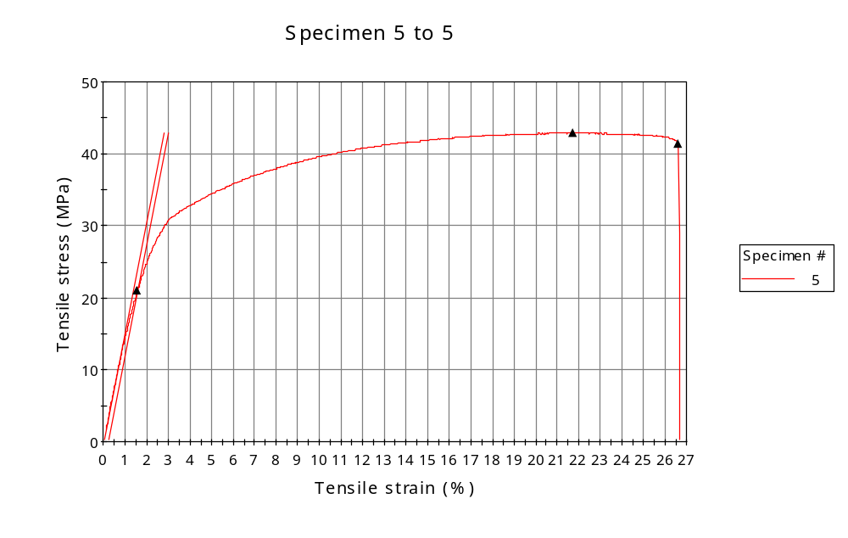
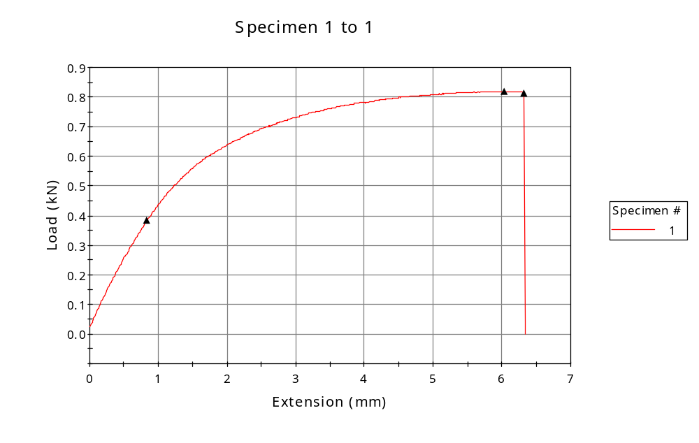
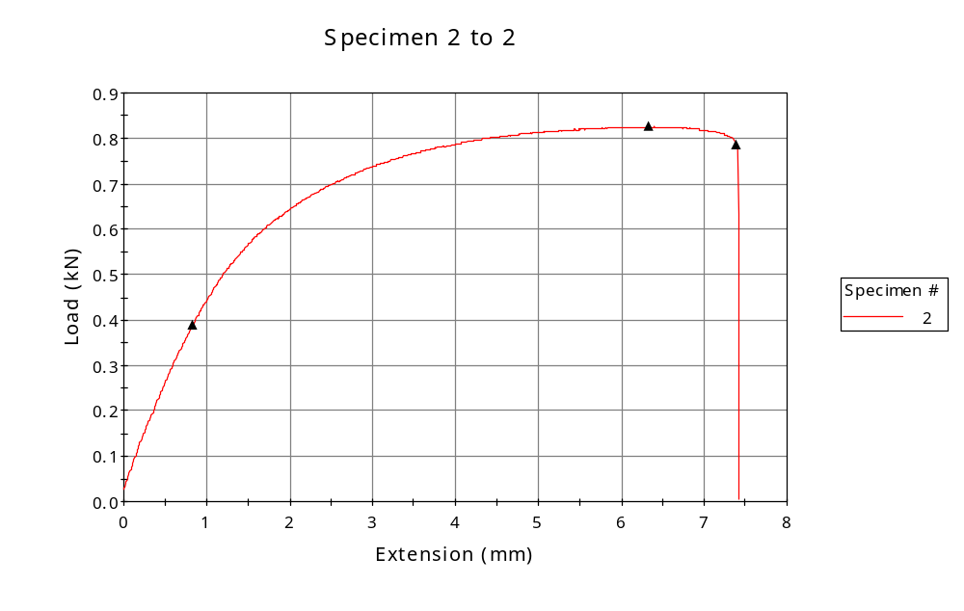
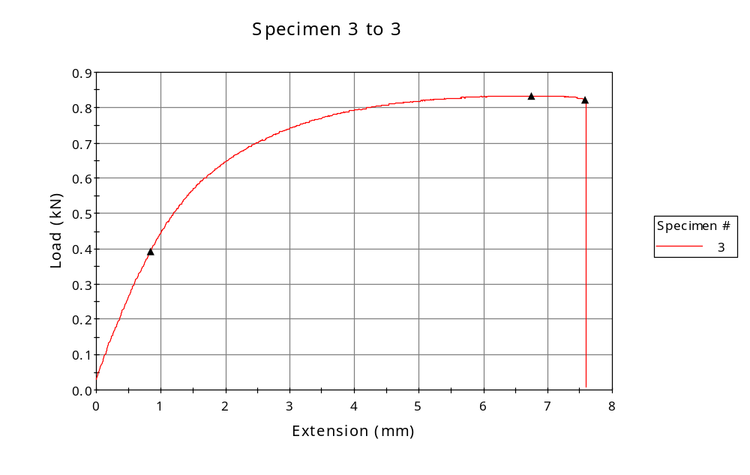
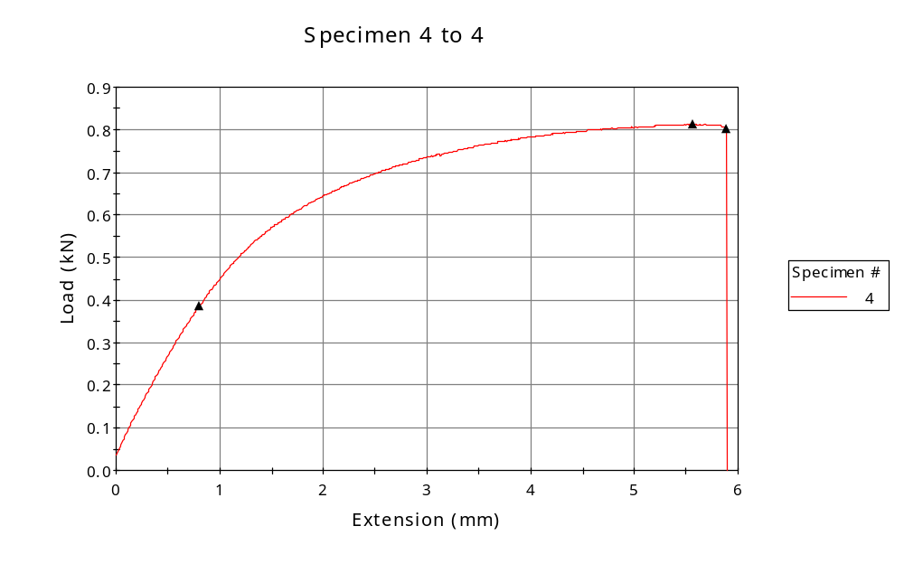
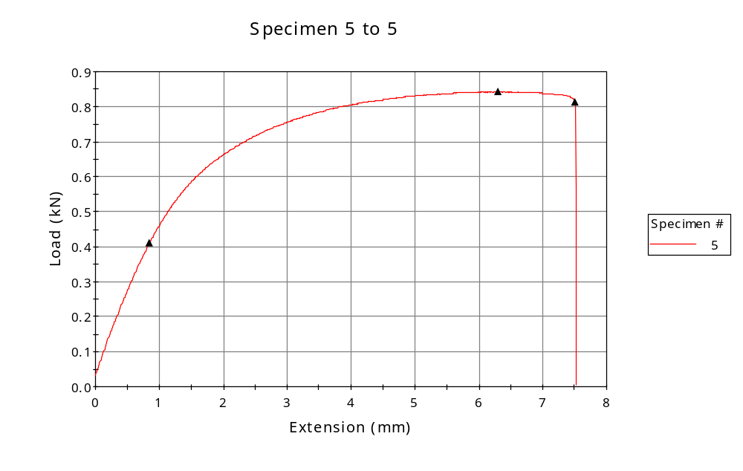

 | CP ID | Length  (mm) | Width  (mm) | Thickness  (mm) | Modulus (Automatic Young's)  (MPa)
1 | CP-SLS_ZX3_01 | 25.00 | 5.98 | 3.25 | 1586
2 | CP-SLS_ZX3_02 | 25.00 | 5.99 | 3.26 | 1571
3 | CP-SLS_ZX3_03 | 25.00 | 5.97 | 3.26 | 1546
4 | CP-SLS_ZX3_04 | 25.00 | 5.97 | 3.27 | 1542
5 | CP-SLS_ZX3_05 | 25.00 | 5.97 | 3.29 | 1539
Maximum |  | 25.00 | 5.99 | 3.29 | 1586
Minimum |  | 25.00 | 5.97 | 3.25 | 1539

 | Load at Fy ( 0.2 %) - LE  (kN) | Tensao em Fy ( 0.2 %) - LE  (MPa) | Deformacao em Fy ( 0.2 %) - LE  (%) | Forca Max  (kN) | Tensao na Forca Max - LR  (MPa)
1 | 0.384 | 20 | 1.456 | 0.820 | 42
2 | 0.388 | 20 | 1.490 | 0.825 | 42
3 | 0.392 | 20 | 1.550 | 0.833 | 43
4 | 0.386 | 20 | 1.485 | 0.812 | 42
5 | 0.412 | 21 | 1.577 | 0.843 | 43
Maximum | 0.412 | 21 | 1.577 | 0.843 | 43
Minimum | 0.384 | 20 | 1.456 | 0.812 | 42

 | Deformacao na Forca Max - LR  (%) | Forca na Forca na Quebra - LQ  (kN) | Deformacao na Forca na Quebra - LQ  (%) | Final length  (mm) | Final width  (mm)
1 | 20.345 | 0.814 | 21.512 | 119.00 | 6.82
2 | 21.677 | 0.786 | 25.943 | 119.00 | 6.82
3 | 23.429 | 0.820 | 26.795 | 119.00 | 6.82
4 | 18.787 | 0.803 | 20.087 | 119.00 | 6.82
5 | 21.738 | 0.812 | 26.605 | 119.00 | 6.82
Maximum | 23.429 | 0.820 | 26.795 | 119.00 | 6.82
Minimum | 18.787 | 0.786 | 20.087 | 119.00 | 6.82

 | Alongamento
1 | 3.76
2 | 3.76
3 | 3.76
4 | 3.76
5 | 3.76
Maximum | 3.76
Minimum | 3.76

